Armando Meraz

CS – 250

Southern New Hampshire University

10/26/2024

7-1 Final Project

Everyone on the team contributed to the success of the project from the Product Owner who takes care of prioritizing the backlog and assuring features are meeting the client/customer's needs. The role of a Product Owner is very important, they are in charge of maximizing the value of any product they undertake and making sure the product vision is met.  The development team also does their part by making sure to create the product in the correct way and assuring their code is clean and addresses the actual requirements. The Scrum Master like me contributes to the success of the project by facilitating the scrum process and assuring the team is following scrum principles and guidelines.

A Scrum-Agile approach to the software development cycle helped user stories come to completion by stressing the importance of team collaboration, adaptability, and continuous improvement. In scrum-agile complex projects called Epics are broken down into user stories which is essentially just breaking down the work into small manageable parts. This allows developers the ability to tackle large projects and still have control over the development process.

The team handled interruptions and new requirements perfectly by promoting constant feedback whether good or bad, by having many iterations cycles we are able to improve the product. The adaptability of the team helped to make sure we were always focused on the sprint goal even with changes thrown our way. There is so much only one person can accomplish, and it is very important to be able to work together in a team in today’s technological world. When working in a team it is crucial to be able to communicate with one another so problems or changes can be addressed in a timely manner. Having good open communication amongst the team will promote transparency and also reduce ambiguity. It also drives up collaboration, when the team can effectively communicate it increases innovation with the exchange of different ideas from different backgrounds. Here is an example from a discussion model:

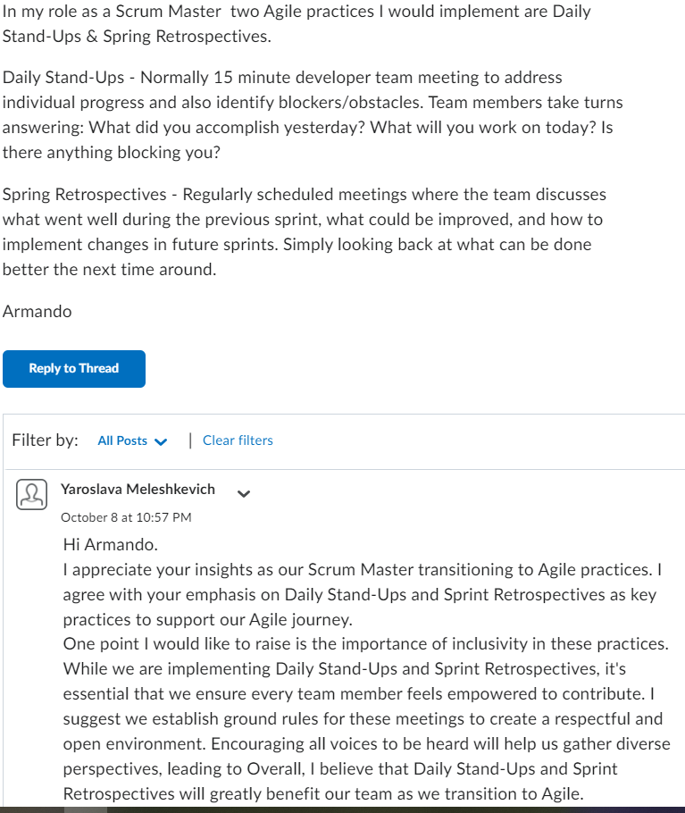

An Agile project management tool that helped the team stay organized is JIRA, through this tool you can keep track of assignments and make changes if needed.” Agile teams can utilize Jira’s backlog to prioritize all their work and tackle a subset of the work in their next sprint.” (Atlassian, 2024).

The pros of the agile approach for our SNHU Travel project is that there is an increased flexibility to be able to adapt to changes in requirements in a moment's notice. Through the Scrum-Agile approach, we are able to deliver cycles at a much faster rate. One of the drawbacks to this approach is the need for the team to be self-sufficient and manageable, which can be difficult for inexperienced developers. I believe the scrum-agile approach is the best approach to the SNHU Travel project because it provides flexibility, continuous feedback, and adaptability which can help a project become successful.

References

Atlassian 2024 <https://www.atlassian.com/software/jira/features>